Welcome to the enVisionMATH Website!

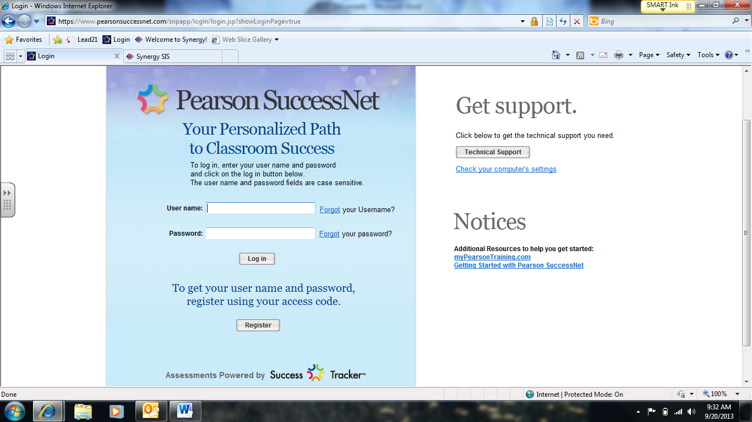

Use your child’s username and password provided by your child’s teacher and click “Log in”.

Click here to explore interactive stories and games.

Click here to explore our math work pages.

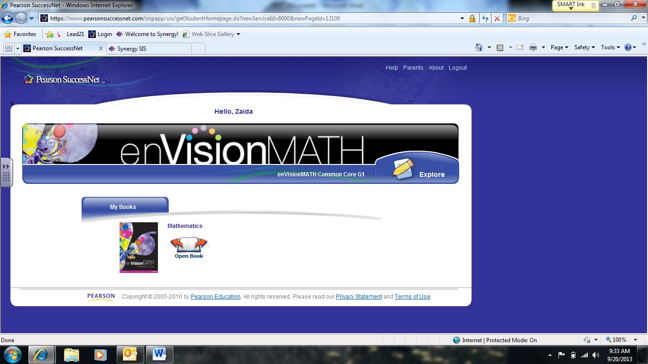

Click “Search” to find math games!

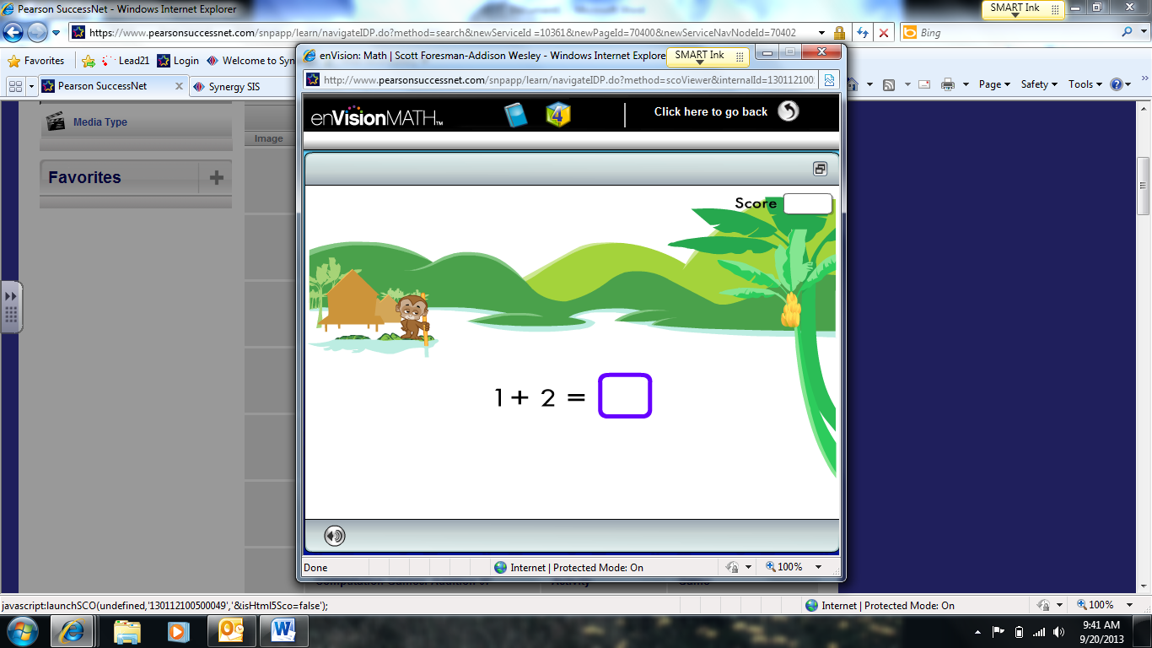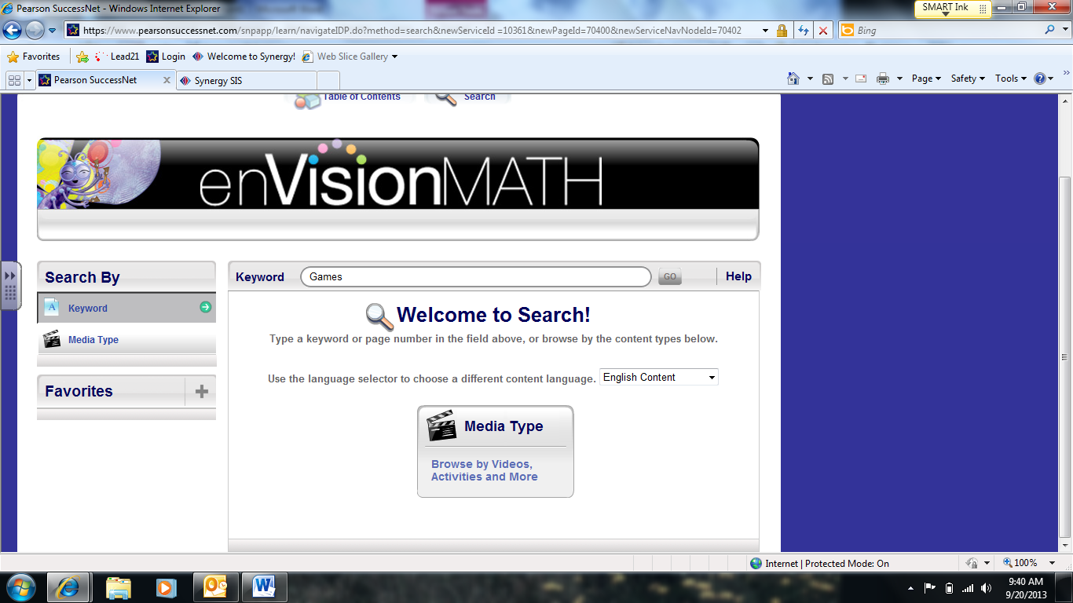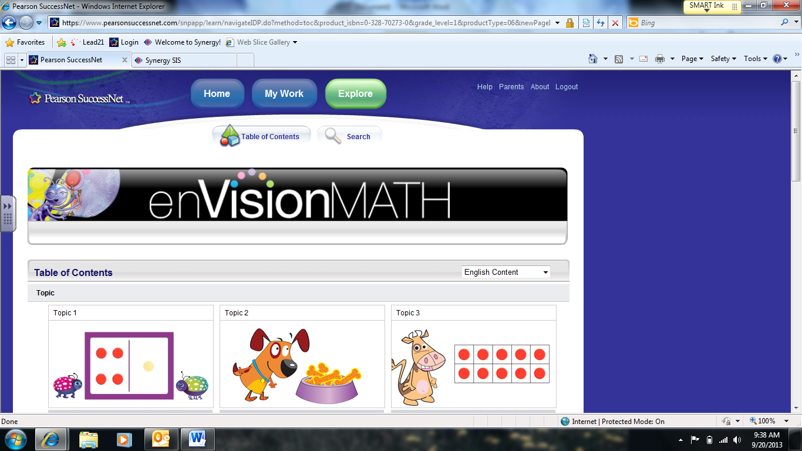

Here is an example of one of the game choices for your student to play to practice math skills!

Type “Games” in the search bar and a list of games will pop up arranged by skill that you can choose from!

Interactive Math Stories Arranged

by Topic.