Fun with Archeology Explorations
These games and challenges go on for 2 pages, so scroll down to find all of the things you can do.
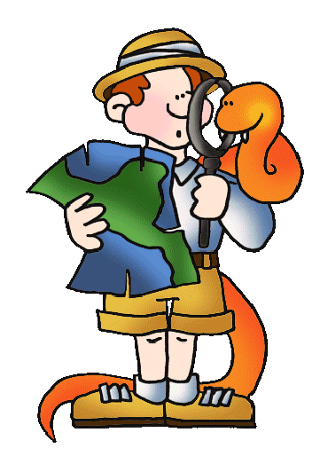
http://www.smm.org/catal/
Mysteries of Catalyohuk

http://www.abc.net.au/science/holo/dembone.htm
Boneyard

http://www.bbc.co.uk/history/ancient/archaeology/launch_gms_hunt_ancestor.shtml
Hunt the ancestors

http://www.nms.ac.uk/education__activities/kids_only/egyptian_tomb_adventure.aspx
Egyptian Tomb Adventure

http://deathinsakkara.wedonicethings.com/
Death in Sakkar: Egyptian Adventure

http://www.bbc.co.uk/history/ancient/egyptians/launch_gms_mummy_maker.shtml
Mummy Maker

http://www.bbc.co.uk/history/ancient/archaeology/launch_gms_divers_quest.shtml
Diver’s Quest

http://www.bbc.co.uk/history/ancient/archaeology/launch_gms_dig_deeper.shtml
Dig Deeper

