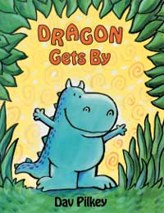
Dragon Gets By

Fantasy

Reading Targets
- I can read words with short vowel sounds a and i.
- I can recognize the make-believe characters and events in a fantasy story.
- I can retell a story by telling the characters, setting, and the beginning, middle, & end.
- I can identify homophone pairs.

Writing Targets
- I can write words with short vowels a and i.
- I can identify a sentence.
- I can write homophones correctly in a sentence.
- I can write words with –s, -ed, and –ing endings.

