Insects Study Guide

I can describe an insect’s environment.

What are things that an insect needs in its environment?

Food Water Shelter Swimming Pool

Protection Friends Air Playground

I can name the stages of incomplete metamorphosis.

Put the stages in order.

_____ adult

_____ egg

_____ nymph

Which insect lays its eggs in water?

Grasshopper Dragonfly Praying Mantis

Which insect lays its eggs in the grass?

Grasshopper Dragonfly Praying Mantis

Which insect lays its eggs in a tree?

Grasshopper Dragonfly Praying Mantis
I can name the stages of complete metamorphosis.

Put these stages in order.

_____ egg

_____ pupa

_____ adult

_____ larva

I can label the body parts of an insect.
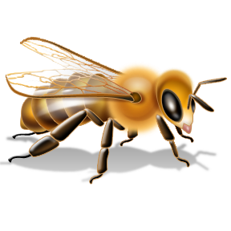

I can identify an insect.

Is a spider an insect? YES or NO

Is a praying mantis an insect? YES or NO

Is a scorpion in an insect? YES or NO

Is a larva an insect? YES or NO

I can classify an insect as helpful or harmful.

How can an insect be helpful? ______________________________

How can an insect by harmful? _____________________________

