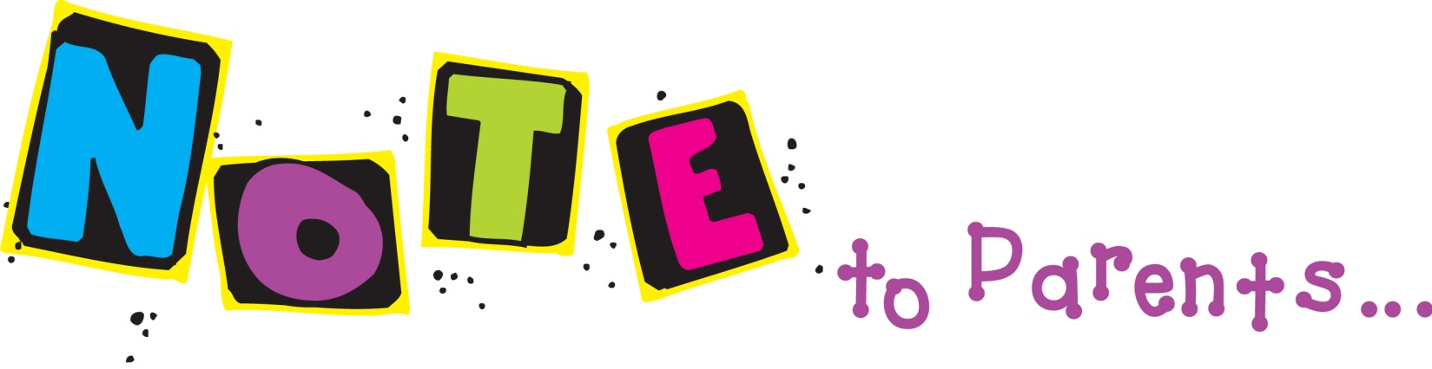

Friday, August 23, 2013
Dear Parents!
Wow! A great first week, although exhausting! It is always a challenge to get back into the routine. Everyone should sleep well tonight! I am really enjoying all your kiddos!
Announcements:
- Field trip to Wilderness Science Center: Monday morning, August 26. Please see the note that was sent home about appropriate attire.
- Because of the heat that is expected next week, if your second grader would like to bring shorts to change into upon our return, that is fine!
- Early Release is Tuesday, August 27. Dismissal is at 2:00.
- Library Checkout is Tuesday morning.

Reading:
This week we will start Theme 1: My Roles. The different skills we will cover determining important information and the author’s purpose. We will work with the phonics skill of long a spelled a-, ai-, ay-, a_e and inflected word endings –s, -es, -ed, -ing.
Math:
We began Topic 1: Understanding Addition and Subtraction. This unit will cover the understanding that addition is the joining of parts to make a whole and that subtraction is the separating of a whole and comparing amounts. Students will also learn that addition and subtraction have an inverse relationship.
We will also begin Kim Sutton Ten Block math fluency by working with odd and even strategies.
Your student brought home a blue math paper attached to their red spelling list. This is the weekly math homework and is due the following Friday.
Science:
We are beginning our study of life cycles by learning about plant parts and plant life cycles.

Spelling:
Your student brought home their first spelling list today. Red spelling lists will come home on Fridays attached to the weekly math. Tests are given on Thursdays.

