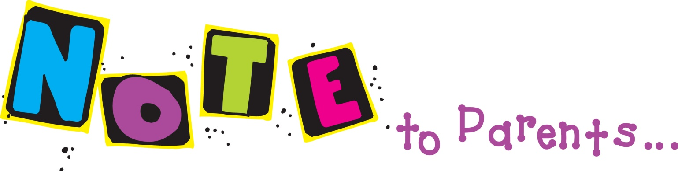

Friday, Sept. 6, 2013
Dear Families,
We had a full week with only 4 days! We have finished learning about plants, and will be shifting to life cycles. We will begin a new math unit. We already have 2 reading quizzes and spelling tests, as well as a math test under our belts!
Announcements:
Monday, Sept. 9: MAP Reading Test: 8:45-?
Tuesday, Sept. 10: Early Release: Dismissal at 2:00!
Tuesday, Sept. 10: Library Checkout!
Thurs., Sept. 12: Spelling Test!
Fri., Sept. 13: Weekly Computation #3 due!

Reading:
This week we will work on making inferences and recall and retell for comprehension work. We continue to work on the use of context clues in developing vocabulary. The phonics skills are long e phonics patterns and the syllable patterns of V/CV and VC/V. The spelling skill is long a words.
We continue to learn our literacy rotations Independent Reading, Writing, Word Work, Listening, and Spelling.
Math:
We will start Topic 2: Addition Strategies. Students will use the addition strategies of adding 0, 1, and 2, doubles, near doubles, associative property of addition, and adding three or more addends to build their math fact fluency for sums up to 20. We will also support this with Adding Zero in the Kim Sutton program.
Science:
We will begin to learn about life cycles of many different kinds of living things!
Have a wonderful weekend and a great week!
Lorraine Sullivan

