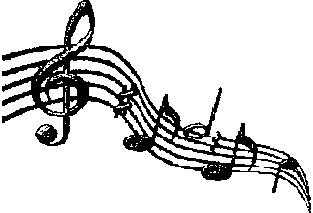
Graphic Organizer: Research Name: _

Composer

Young Life/Family
Musical Time Period

Education & Motivation

*

*

*

*

*

*

Major Music Contributions
(titles and types)

*

*

*

*

*

*
*

*

*

*

*

*

What things might be different in music
today than they were in your composer’s time?

*

*

*

*

*

Other items of interest/Unusual facts

*

*

*

*

*

*

*

*

*

*

