Scientists

are

can

have

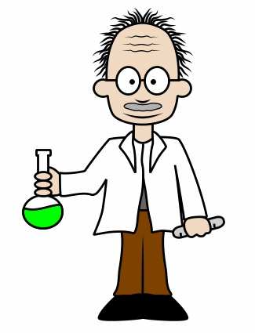

Scientists

are

can

have