7th Grade Integrated Algebra & Advanced Integrated Algebra
Mrs. Melissa Davis
Mdavis05@bluevalleyk12.org
913-239-5858

Welcome back to a brand new school year at Lakewood Middle School. This is my first year at Lakewood, but I have been teaching for 4 years. I graduated from Kansas State University and, most recently, finished my masters through Baker. Outside of school, I love spending time with my husband and our dog, Buffy. I am so excited to be teaching 7th grade and am looking forward to getting to know each child in my class. It is my hope that you will take this opportunity to seek out the challenges ahead of you in order to have a rewarding year in 7th grade math.

- Expectations - If you never try you will never succeed, so I expect that you will always do your personal best and attempt the task at hand. In addition, you should come to class prepared and ready to learn.

- Units
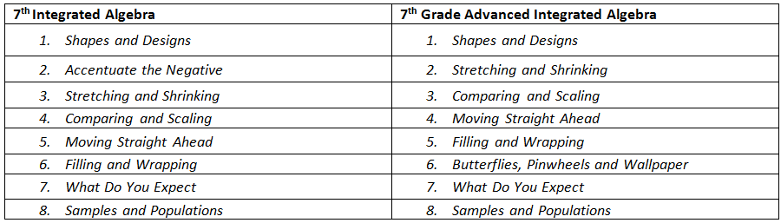

- Grades - Students will be evaluated on homework, quizzes, tests, projects, and class participation.
  - Homework/Participation 25%
  - Projects/Assessments 75%

- Ask Questions – I am available on Wednesday mornings from 7:00 – 7:30 a.m and most days after school until 3:15. Any student that needs extra help can receive it during these times. However, please come in with specific questions. Other times can be scheduled on an “as needed” basis, but students must make arrangements for help in advance.

- Absences - Please check Synergy for what you missed. I post a weekly agenda, which provides daily activities and homework. Also, ask a friend from class for details. You are expected to take responsibility for your make-up work.

