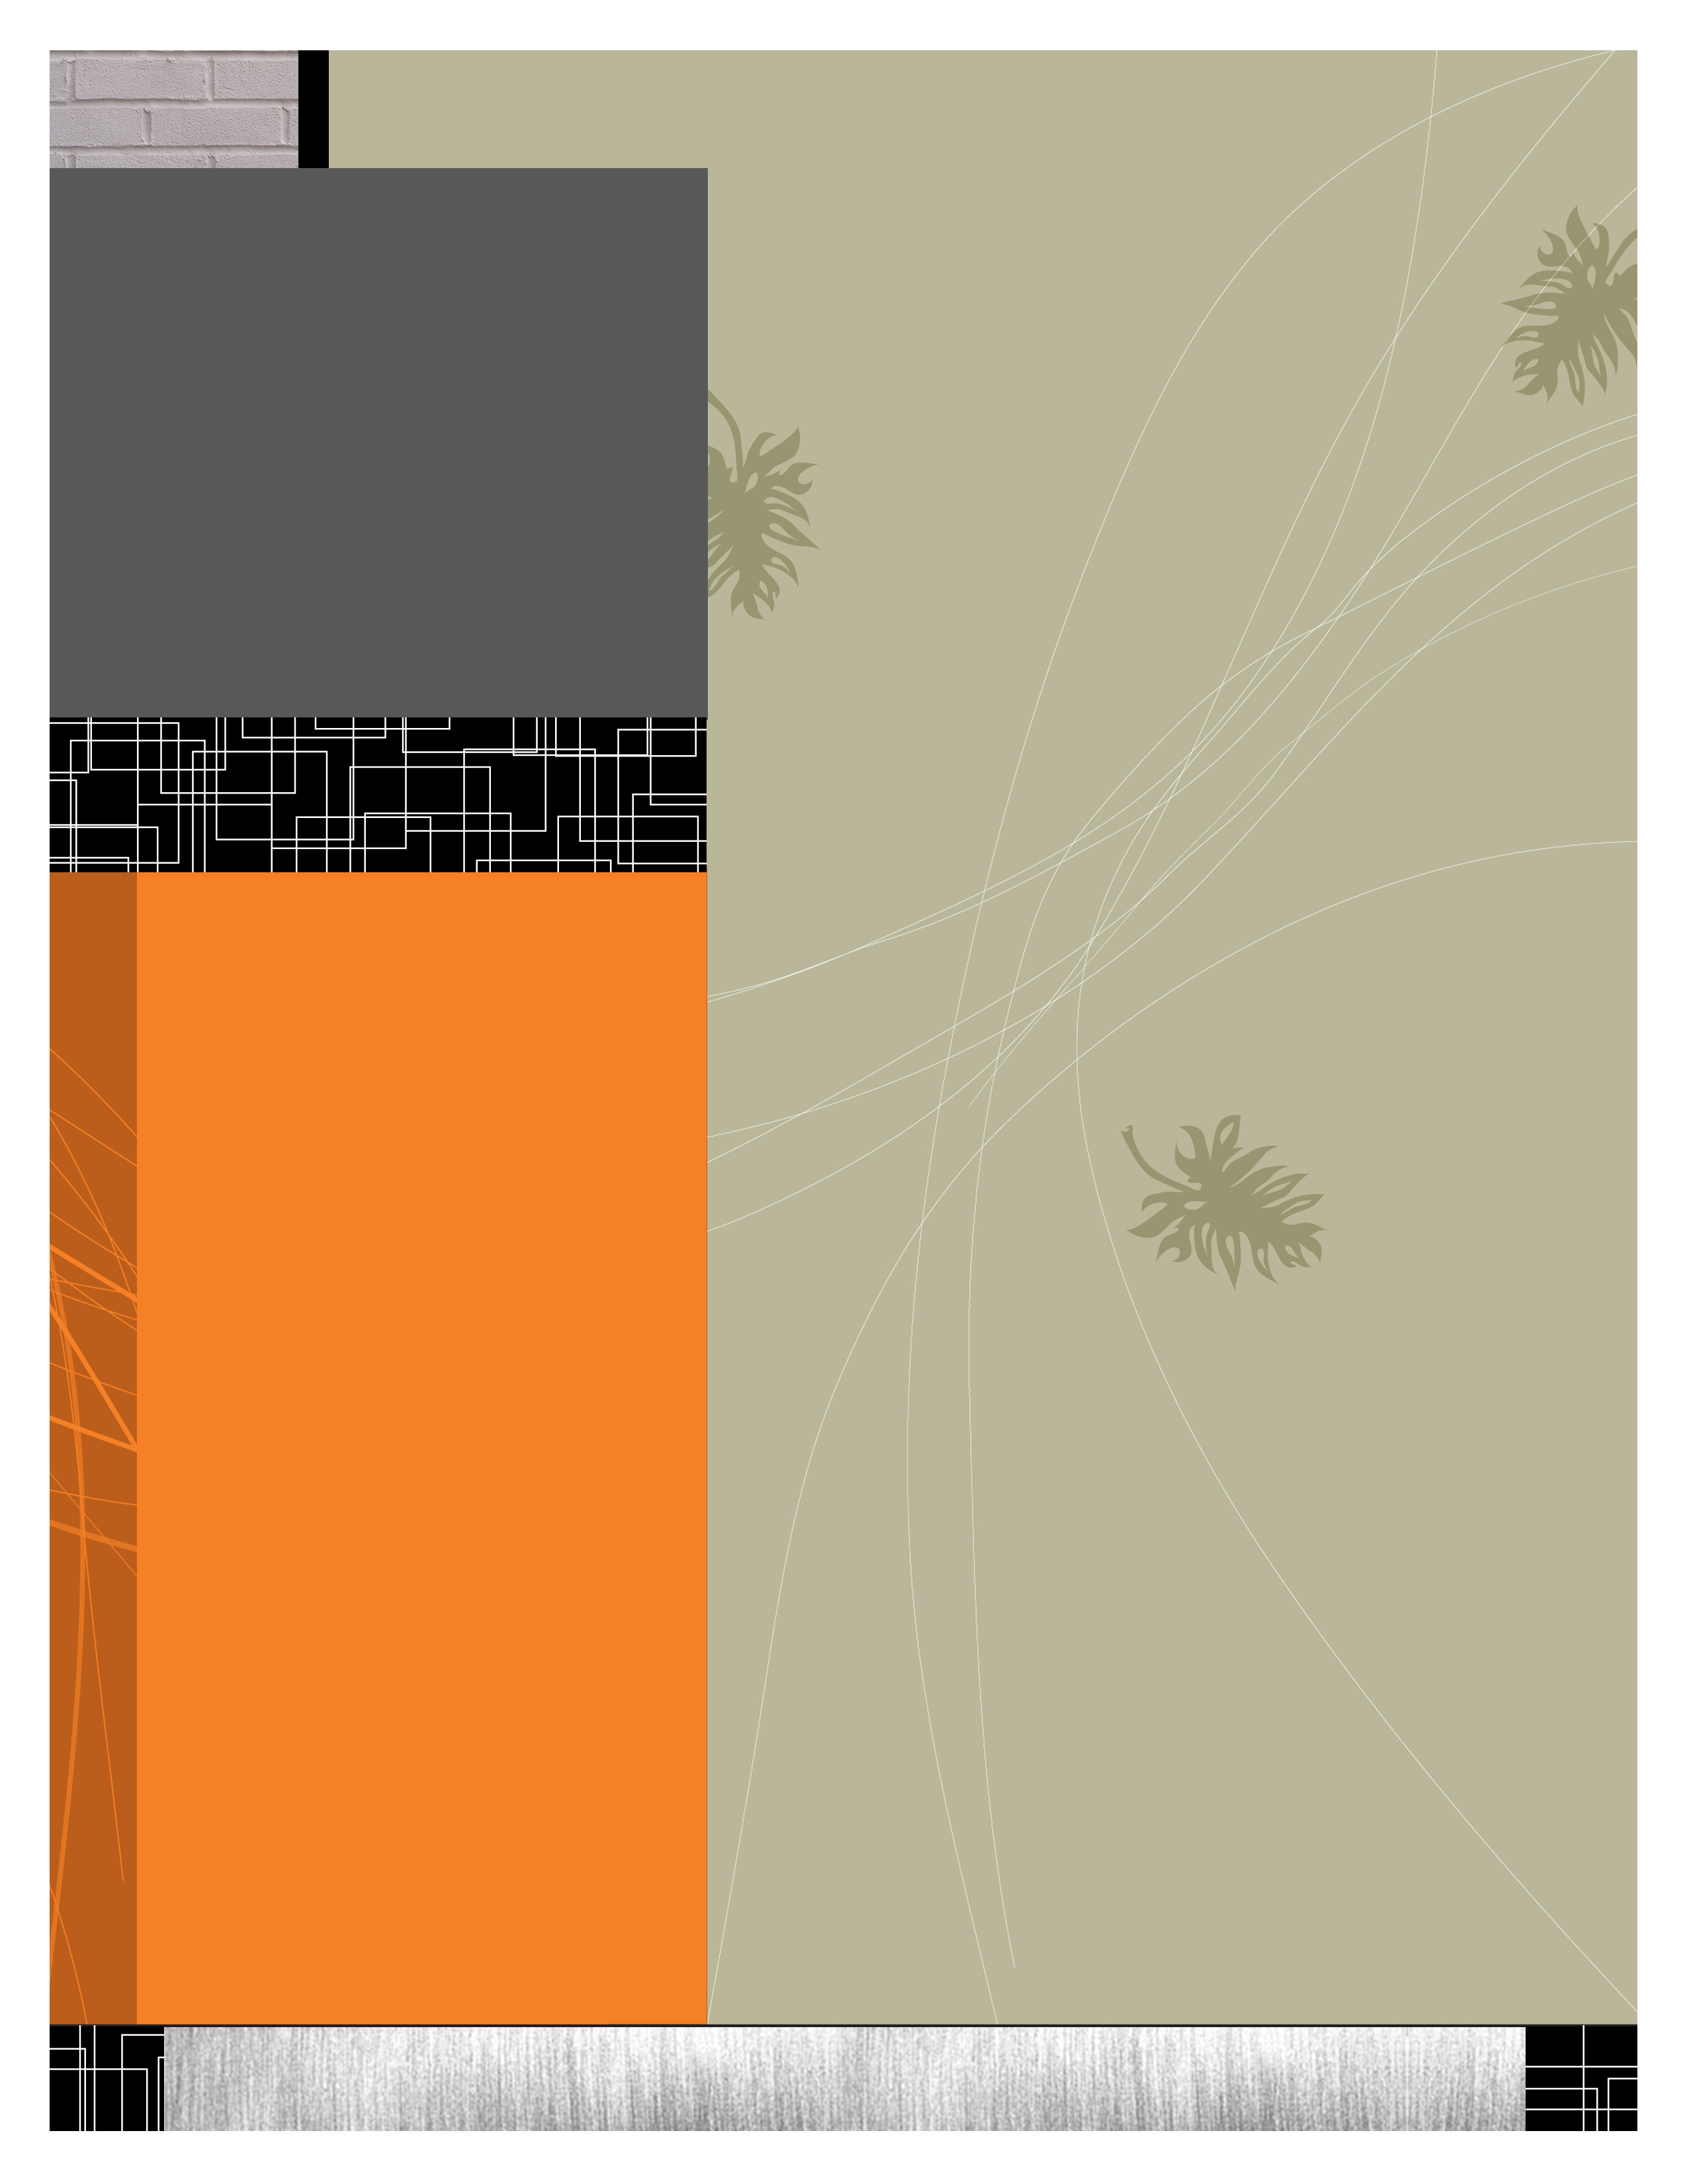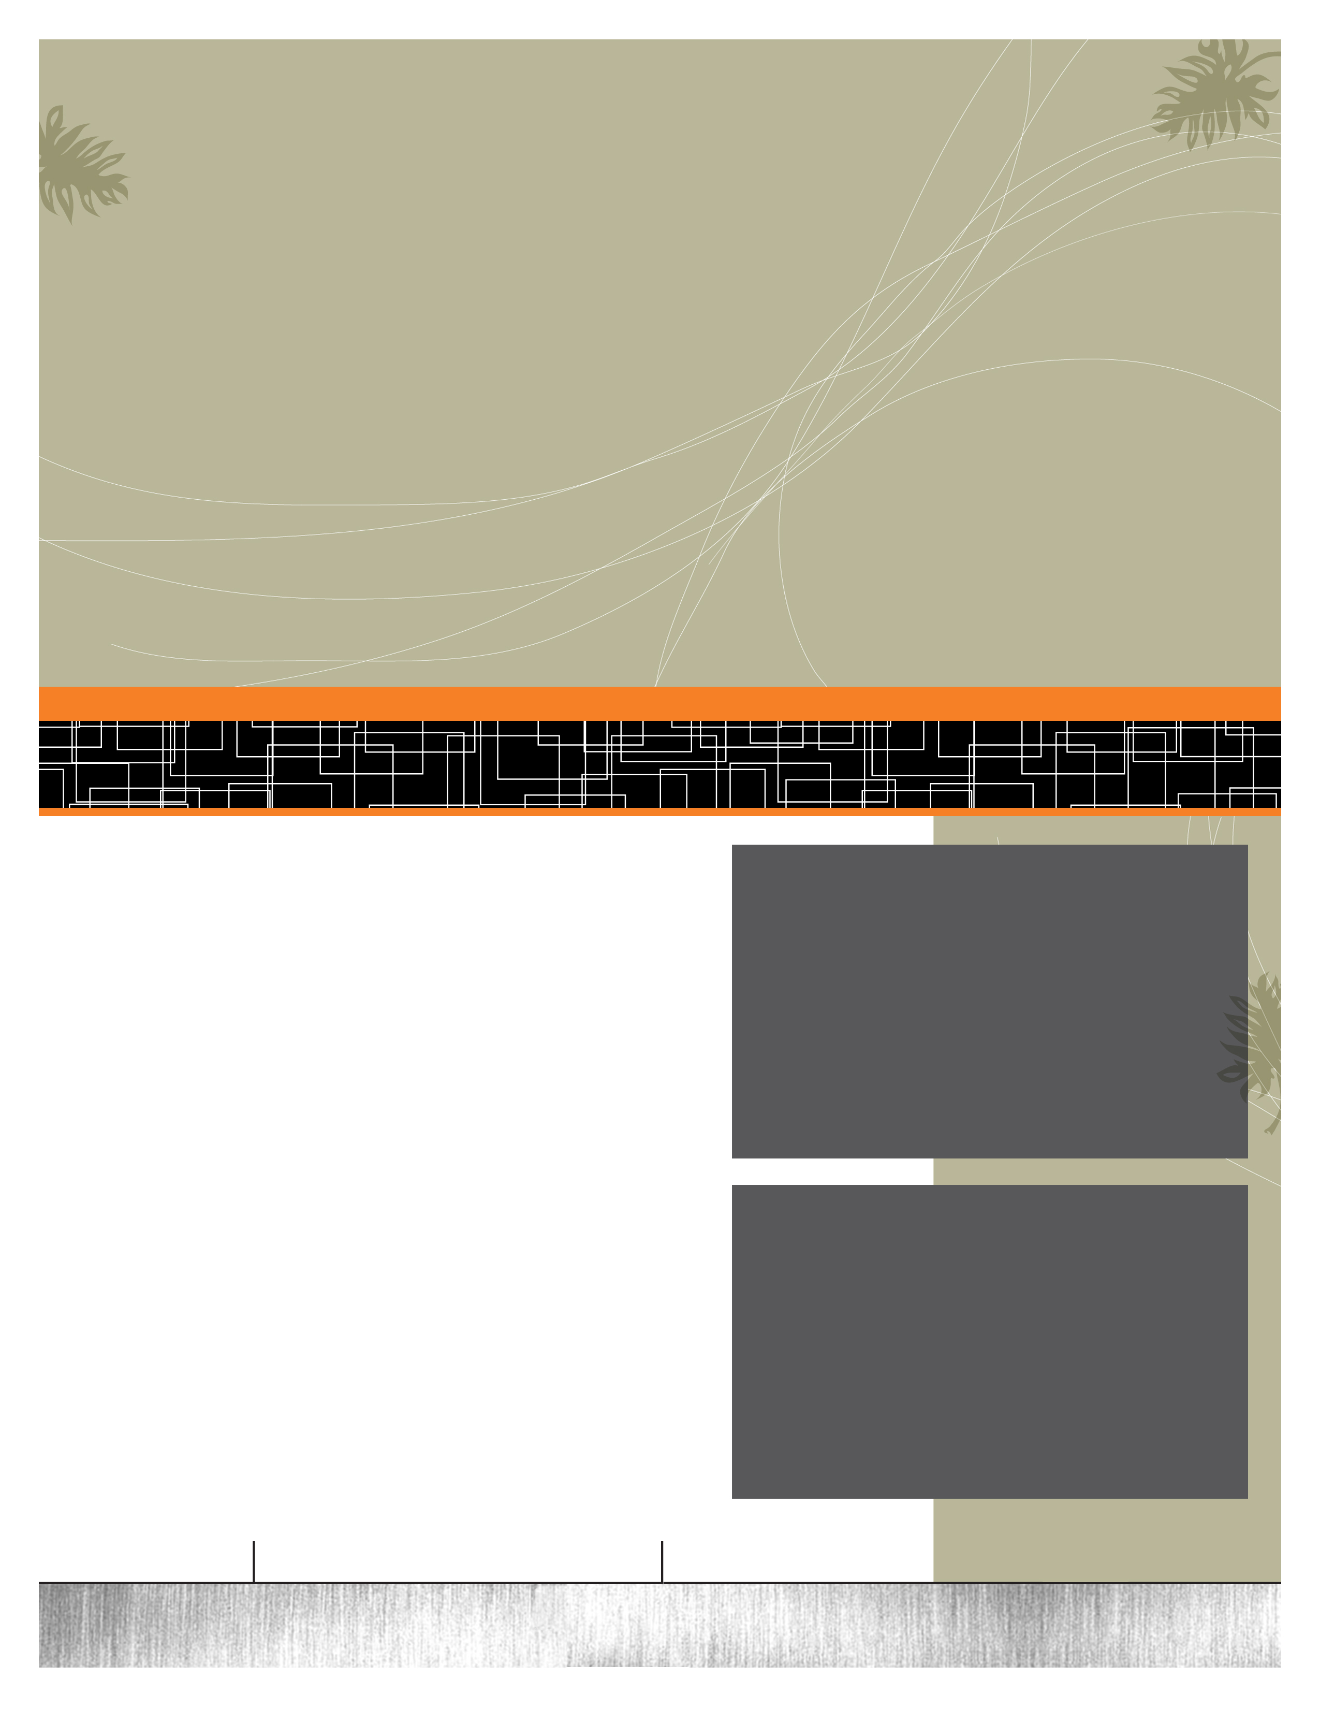

2012/2013

READING/CA

Classroom Expectations

· Students are expected to be in class on time and use the time in class in a positive and constructive manner. Excessive absences will hinder a student’s learning.

· Students are expected to be prepared every day. This includes having daily assignments completed, coming to class with all supplies, and being prepared for tests.

· Students are expected to respect others in the class by paying attention, letting others pay attention, and doing what is asked.

Absences & Make-up Work

District guidelines allow two days for each excused absence in which to complete make-up work. Assignments are usually posted on School Center. I encourage all students to come see me when they know they will be absent.

Once the student returns, they should contact me before or after school to receive any worksheets, tests, or instructions missed while absent.

Make-up work not turned in according to these guidelines may receive partial credit or no credit unless the student has talked with me, and we have made other arrangements.

Grading

The grades for Reading and Communication Arts will always be the same. I will continue to update CA grades and transfer the grade to Reading before progress reports.



**A bit about Mrs. Gerner**

I am very excited to be working with your child this year. This will be my sixth year at Lakewood teaching 7th grade. I graduated from Kansas State University with a degree in elementary education and middle level English. Being a native Nebraskan, I cheer for my Wildcats but bleed red.

As a teacher, I love to incorporate technology and hands-on learning.

I fully believe that teacher and parent communication is essential to enhancing learning opportunities. Please never hesitate to contact me. The most effective and quickest form of communication with me is through email.

sgerner@bluevalleyk12.org

**Sara Gerner**

**Sgerner@bluevalleyk12.org**

**VM 239-5873**

2012-2013

Vocabulary

Increasing student vocabulary is the key to a successful education. This year’s vocabulary words will come from the common core state standards, content areas, and outside reading. Unit tests will be given to each student. The vocabulary books aligned with the common core standards will come from Sadlier’s ***Vocabulary for Success Level C*** workbooks. Because of state wide budget cuts, we will be using class sets of the workbook. If you would like to purchase an individual book for your child, you may access the information at:

<http://www.sadlier-oxford.com/catalog/category.cfm?category_id=10990&qpath=1705>

Please note that this purchase is $15.69 and OPTIONAL. Sadlier recognizes Level C as an 8th grade book, but we will be using it at the 7th grade level.

If you have more questions, please do not hesitate to contact me.

Reading

I strongly encourage reading outside of the classroom expectations. This year students will be required to constantly have an outside reading book. They will use this book to help increase their use of vocabulary, research methods, writing skills, and literature analysis within the classroom.

As parents, the best way to increase your students reading ability is to constantly have conversations about their readings and model positive reading yourself.

Grammar and Writing

Grammar will be reinforced daily, but heavily studied and learned every Thursday. Writing will also take place daily and be structured off of the Common Core State Standards. Your student will learn about different text types and their purposes, the production and distribution of writing, and how to display a wide range of writing. We will also spend a great amount of time researching to help students build and present their knowledge. These skills will all be applied using the 6+1 traits of writing and the writing process.

Reading and Communication Arts

When we hear Reading and Communication Arts, we often think of two separate classes. At one point this was true; skills were taught in one class and reinforced in another. But the reality of it is that reading and writing skills are so intertwined, separating them can hinder instead of enhance your student’s learning. Today, skills and techniques are taught and revisited in *both* classes, often becoming more in-depth and advanced along the way.

Links

· Online textbooks for Reading, Language, and Social Studies:

www.gohrw.com (user name:lkm1 password: lkms)

· Assignments will usually be posted on School Center

www.bluevalleyk12.org/education/staff/staff.php?sectionid=624&

· Common Core 7th grade handout: http://www.pta.org/7thGradeFeb4.pdf

· Students will be studying vocabulary words. Many of these words can be found on at *Sadlier-Oxford Vocabulary Workshop*. This site includes an audio program and online activities.

www.vocabularyworkshop.com

· Links to these sites are also available through the Lakewood Middle School website

www.lkms.org

Learning for life

Keeping kids safe

Making a difference

Striving for excellence