MUNCHKINS
Below is a list of costume requirements for you to start looking for as soon as possible. Please note, all costume items are due to Ms. Rodenbeek the week after Winter Break! That means, you need to get everything to me before January 8, 2016! Do not wait until the due date to work on your costume! The sooner you get everything to me, the better!!
All costumes for the Munchkins should be bright and colorful. Please remember, you can mix and match any color you would like!
  - Sweatpants
  - Striped stockings or tights
  - Button-down shirt with large collar
  - Fanciful hat
OR
  - Knee-length dress or skirt with an empire waist (high-waisted)
  - Striped stockings or tights
  - Fanciful hat, ribbons, and/or bows

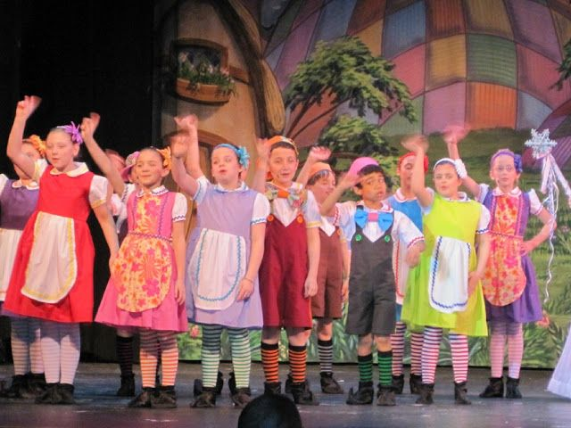
If you have any questions or concerns, email Ms. Rodenbeek at crodenbeek@bluevalleyk12.org.

THREE TOUGH KIDS/LOLLIPOP GUILD
Below is a list of costume requirements for you to start looking for as soon as possible. Please note, all costume items are due to Ms. Rodenbeek the week after Winter Break! That means, you need to get everything to me before January 8, 2016! Do not wait until the due date to work on your costume! The sooner you get everything to me, the better!!
All costumes for the Munchkins should be bright and colorful. Please remember, you can mix and match any color you would like!
- Sweatpants
- Striped stockings or tights
- Button-down shirt with large collar

If you have any questions or concerns, email Ms. Rodenbeek at crodenbeek@bluevalleyk12.org.
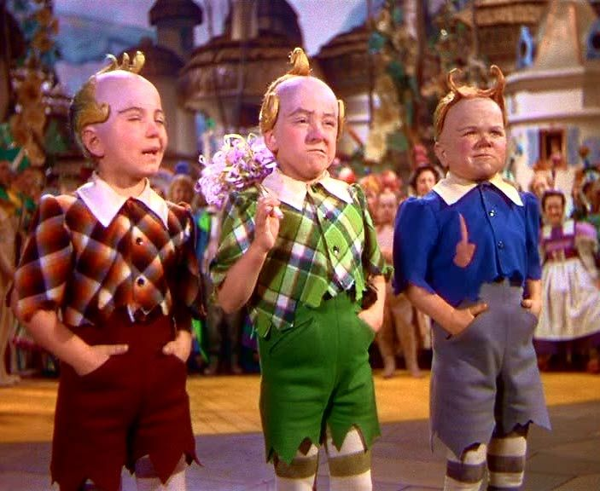

JITTERBUGS
Below is a list of costume requirements for you to start looking for as soon as possible. Please note, all costume items are due to Ms. Rodenbeek the week after Winter Break! That means, you need to get everything to me before January 8, 2016! Do not wait until the due date to work on your costume! The sooner you get everything to me, the better!!
- Black leotard/black t-shirt
- Black tights
- (Black shorts)

If you have any questions or concerns, email Ms. Rodenbeek at crodenbeek@bluevalleyk12.org.

*Please do not include any logo or team name on costume items. Solid colors only!

CROWS
Below is a list of costume requirements for you to start looking for as soon as possible. Please note, all costume items are due to Ms. Rodenbeek the week after Winter Break! That means, you need to get everything to me before January 8, 2016! Do not wait until the due date to work on your costume! The sooner you get everything to me, the better!!
- Black leotard/black t-shirt
- Black tights

If you have any questions or concerns, email Ms. Rodenbeek at crodenbeek@bluevalleyk12.org.
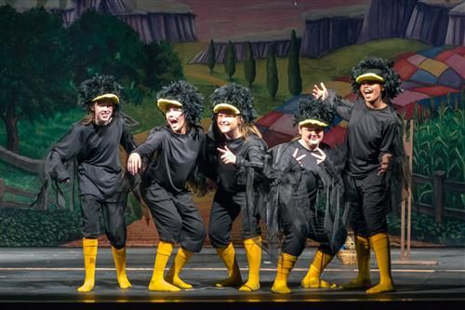

*Please do not include any logo or team name on costume items. Solid colors only!

APPLE TREES
Below is a list of costume requirements for you to start looking for as soon as possible. Please note, all costume items are due to Ms. Rodenbeek the week after Winter Break! That means, you need to get everything to me before January 8, 2016! Do not wait until the due date to work on your costume! The sooner you get everything to me, the better!!
- Dark Green long sleeve shirt
- Brown pants
- Brown shoes

If you have any questions or concerns, email Ms. Rodenbeek at crodenbeek@bluevalleyk12.org.

*Please do not include any logo or team name on costume items. Solid colors only!

WINGED MONKEYS
Below is a list of costume requirements for you to start looking for as soon as possible. Please note, all costume items are due to Ms. Rodenbeek the week after Winter Break! That means, you need to get everything to me before January 8, 2016! Do not wait until the due date to work on your costume! The sooner you get everything to me, the better!!
- Grey Leotard
- Grey Tights/Leggings
- Royal Blue Shorts

If you have any questions or concerns, email Ms. Rodenbeek at crodenbeek@bluevalleyk12.org.

*Please do not include any logo or team name on costume items. Solid colors only!

WINKIE GUARDS
Below is a list of costume requirements for you to start looking for as soon as possible. Please note, all costume items are due to Ms. Rodenbeek the week after Winter Break! That means, you need to get everything to me before January 8, 2016! Do not wait until the due date to work on your costume! The sooner you get everything to me, the better!!
- Grey long sleeve shirt
- Black pants

If you have any questions or concerns, email Ms. Rodenbeek at crodenbeek@bluevalleyk12.org.

*Please do not include any logo or team name on costume items. Solid colors only!

OZIANS AND OPTIMISTIC VOICES
Below is a list of costume requirements for you to start looking for as soon as possible. Please note, all costume items are due to Ms. Rodenbeek the week after Winter Break! That means, you need to get everything to me before January 8, 2016! Do not wait until the due date to work on your costume! The sooner you get everything to me, the better!!
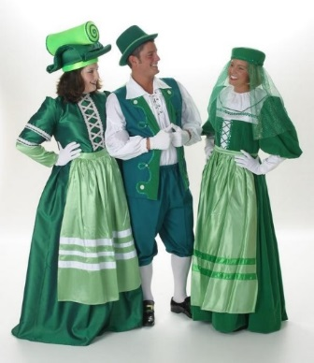
- Full green costume (think St. Patrick’s Day!)
- Possible options:
  - Green long sleeve shirt or leotard
  - Green pants or tights
  - Green dress or robe
  - Fancy green hat
  - Green gloves

If you have any questions or concerns, email Ms. Rodenbeek at crodenbeek@bluevalleyk12.org.
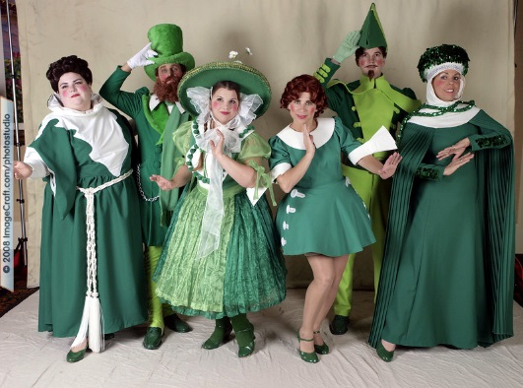

*Please do not include any logo or team name on costume items. Solid colors only!

