Log into the Pearson link on Edmodo and/or StudentVue using your school email and bv+StudentID
Pearson Login (Lit Book)
https://sso.rumba.pearsoncmg.com/sso/login?profile=eb&service=https://k12integrations.pearsoncmg.com/ca/dashboard.htm&EBTenant=BVUSD-KS
*Log in
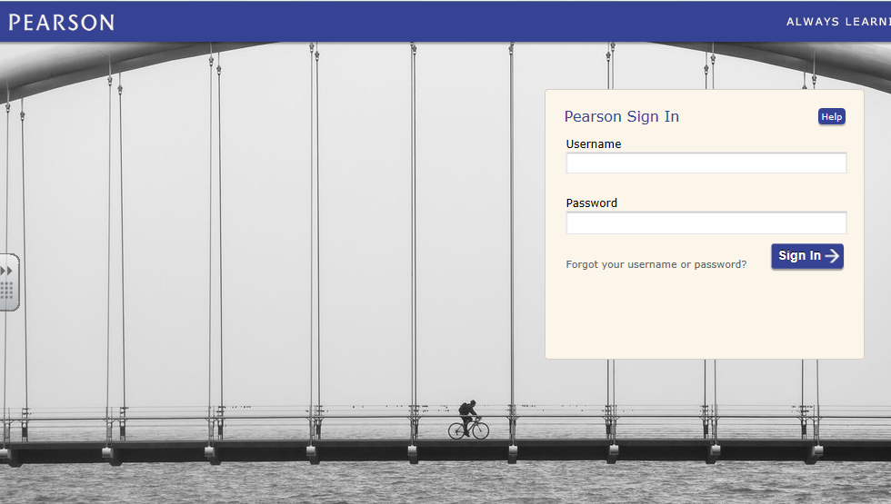

*Click on Realize

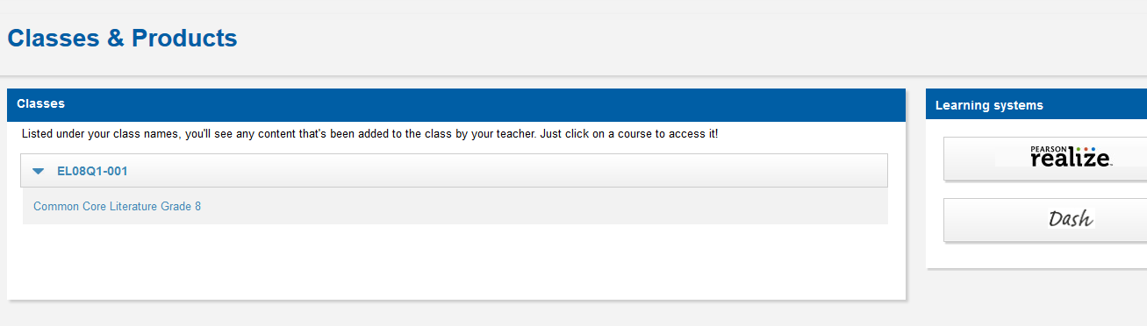

*Choose English (first time setup only)

*Choose a Profile Image, then scroll down and choose a Homepage Image
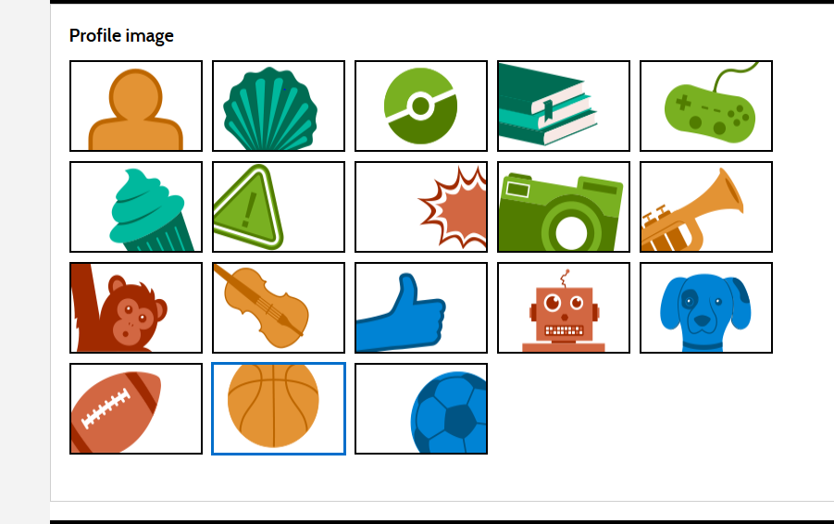

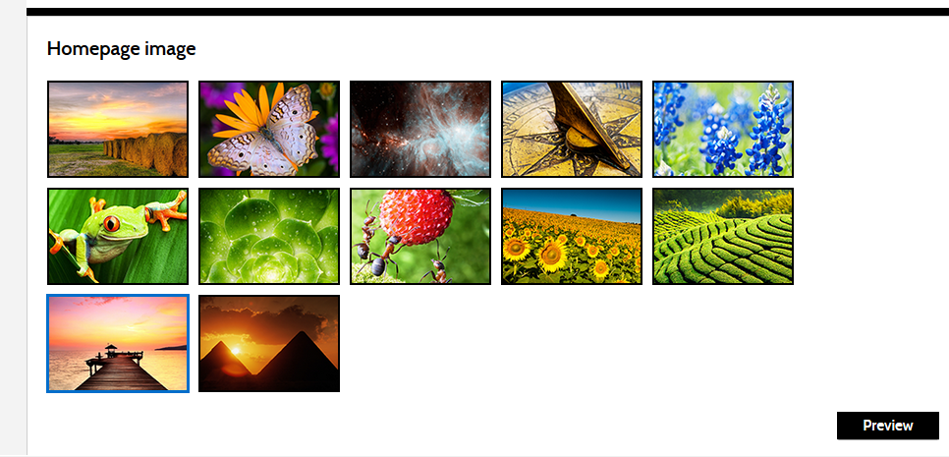

*Choose your program (Common Core Literature Grade 8)
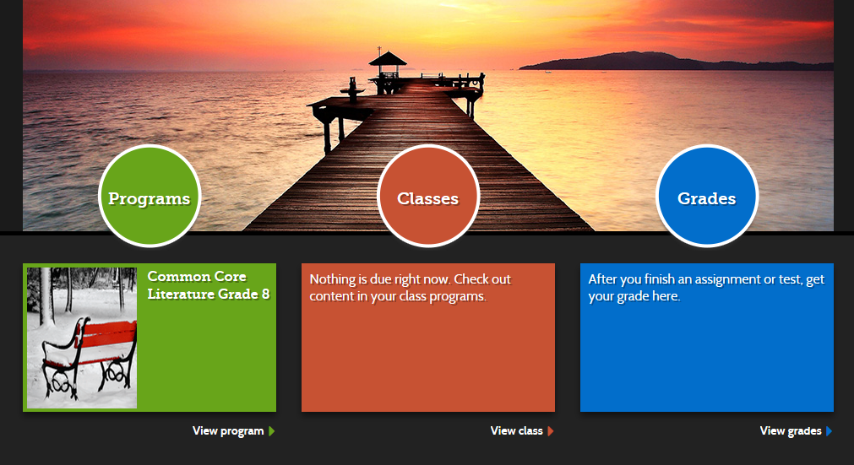

*Enter your page number or search for your story
