My Vocal Range Analysis Sheet
Name________________________
Class/Hour ______ Date _____________

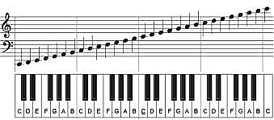

Choose 5 words from the list below that you would choose to describe how you think your voice sounds or feels. Then write why you chose that word.

Bright
Strong
Loud
Soft
Breathy
Light
Nasal
Open
Thin
Thick
Gravelly
High
Medium
Low
Tight
Relaxed
Free
Rough
Shrill
Ringing
Shaky
Booming
Balanced
Deep
Simple

Word Reason I Chose This Word for My Voice

_______________ _________________________________________________________________

_______________ _________________________________________________________________

_______________ _________________________________________________________________

_______________ _________________________________________________________________

_______________ _________________________________________________________________

