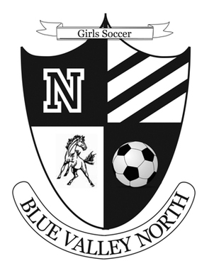
Blue Valley North High School
MUSTANG SOCCER

Youth Camp 2016

Come meet and train with the BVN Coaching Staff & Players!
Games, practices, skills, lots of fun & a t-shirt!

Who: Players in grades K – 8
What: Blue Valley North High School Youth Soccer Camp
When: Sunday July 10th – Tuesday July 12th, 5:30pm – 7:00pm
(Wednesday July 13th will be used as “rain day” if needed)
Where: Blue Valley North Soccer Fields
Why: To receive instruction from Blue Valley North Soccer Coaches & Players
Camp Instructors:

Jason Lee – BVN Boys Varsity Soccer Coach & Girls JV.

Tim Wiseman – BVN Girls Varsity Soccer Coach

Tom Holland – BVN Boys & Girls C-Team Soccer Coach
Current & Former BVN soccer players
***In order to guarantee shirt size please register by July 1st***
Cost: $45.00
Make Checks Payable to: Jason Lee
Mail to: Jason Lee
10254 Eby Court, Apt 1
Overland Park, KS 66212

Detach below and return with payment

Player Name: Grade:
Parents Name:
Address:
Phone #: _ (H) _______________________(C)
Email: _______________________________________________
_______________________________________________
T-shirt size: YS YM YL AS AM (circle one)
Disclaimer: I hereby release the Mustang Team Camp and the camp directors from any and all liability for injuries, illness or loss of property that may be incurred or suffered while attending the camp.
Parent/Guardian Signature:

