Peer Tutoring
Assignment 4
Due February 15/16

Go to the following website: http://www.specialed.us/autism/structure/str11.htm

Read in more detail about visual schedules. After completing the reading, you will need to create your own visual schedule. Remember that visual schedules are not always about your schedule for the day. They may also be used for a task such as washing the dishes. For this type of schedule you would break down the task into multiple steps and then give a picture and/or word representation to show the steps. Look at the examples below. If you would like suggestions of visual schedules that would be beneficial for students you are working with, please contact your Peer Tutoring teacher. Be creative and find ideas beyond the usual (school schedule, morning routine).

Requirements of the Visual Schedule:
*Submit approval form (worth 5 Points) by February 10 (Your project must be approved before you can start)
*Computer generated visuals
*Placed on card stock, file folder, or other sturdy background (not printer paper)
*Provide a place to check off steps of task or use velcro so student can remove each step as completed
*Completed visual schedule due February 15/16

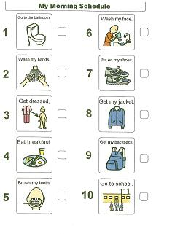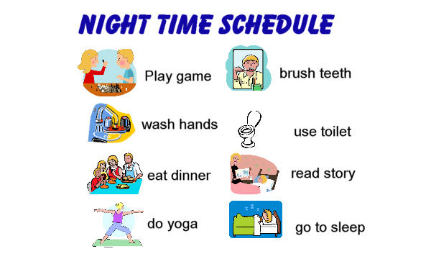

Visual Schedule Approval
Topic of visual Schedule: (Specific task, daily schedule, routine schedule)

Format of the visual schedule: (what set up will you use ie using a folder or book, etc., how will you organize the schedule, and types of materials)

Why did you choose the type of schedule? (Age of individual, cognitive ability of individual, specific disability of the individual, skills being addressed in class) Explain in your own words.

Approved:____________________________________ Date:________

