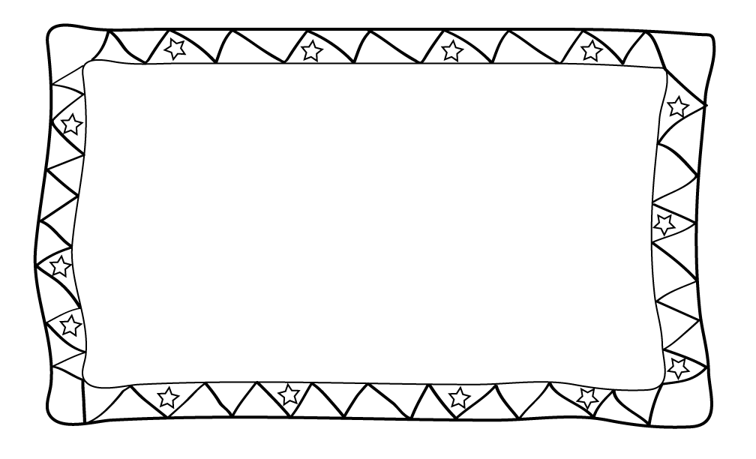

Dear Parents,

__________________________ will be our next Star Student of the Week! This is an opportunity for your child to introduce himself/herself to the class! Please complete the included **poster** with your child and return it to school on _____________________________________________________________.

During your child’s week please send in something special for every day.

**Monday: Completed Poster**

**Tuesday: Family Pictures**

**Wednesday: Favorite Stuffed Animal**

**Thursday: Favorite Book**

**Friday: Estimation Jar**

Another component of this week is the **estimation jar**. Please send in the Estimation Jar filled with **no more than 100 items**, because our objective is to teach estimation between 0-100. Please do not let your child know the number of items in the jar, so your child will be able to estimate, also. This is a fun and exciting way to practice estimation. Some examples might include: pennies, cotton balls, buttons, candy etc. Feel free to be creative!

Thank you for your participation and I look forward to a fun filled week together!

Thank You,

Mrs. Miller

