**Participant – Register Online for Jump Rope For Heart!**

**Step 1:** Log in to your Headquarters web page by visiting www.heart.org/jump **to find your school and sign up!**

You get to create a Jump Rope For Heart Web Page and YOU will raise more life-saving donations! To get started, Register today and join your School Team. Here’s how…





**Step 2:** In the **Search For a Team** form, select your **state, city and/or first letter of your school name**. A list of school names will open.

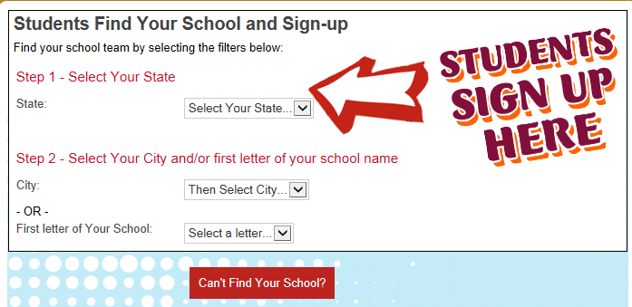

**Step 3:** When you find your school, click the **Join Team** hyperlink.

u

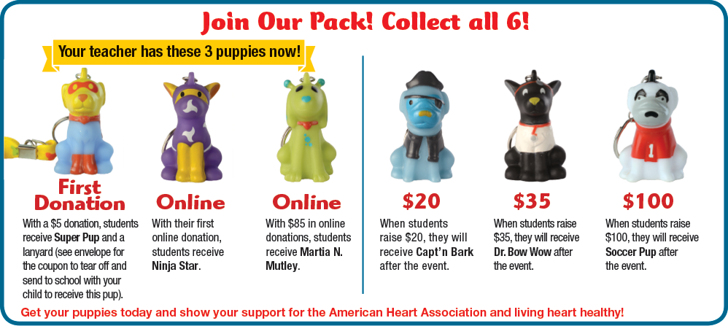

**Congratulations!**

**You have registered for Jump Rope For Heart online!**

Your next step is to email your family and friends using the email tab in your Headquarters. Start receiving Super Pup, Ninja Star, Martia N. Mutley & Capt’n Bark as you raise donations!

**Step 6:** A **Share With Your Friends** screen will pop up. Enter a message that you would like to share via social media and click on the program/s that you would like to use. Once you are done, click the **Publish** button. (Click the “X” in the upper right hand corner of the pop up box to skip this step.)

*\*You’ll see your Headquarters and set up your web page!*

**Step 5:** Fill out the registration steps**.** The last step of registration is an Online Waiver/Agreement. Review the waiver/agreement with your parents and click **”I Agree”** to accept it.

**Step 4:** Create your own **Username and Password** and answer a security question. Click Continue. *\*\*Be sure your Username and Password are easy to remember. Write them here so you don’t forget:*

*My Username: __________________________ My Password: __________________________*

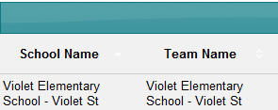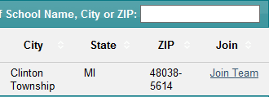

**Step 6:** **A Share with your Friends** pop-up box to share on social media will appear. To share, click the check box of the social media icons you use and click **Publish**. Click the “x” to close the box if you don’t want to share now.