BOOKWORMS IN 2ND GRADE
- Kids Who Read, Succeed! The amount of time that students spend reading for fun is the key predictor of students’ academic achievement. (Gallik, 1999)
- It Take Practice! Reading, like playing a musical instrument, is not something that is mastered once and for all at a certain age. It is a skill that continues to improve through practice. (“Becoming a Nation of Readers” 1985)
- Role Models Matter! Students who see adults reading daily or weekly tend to read more and have higher reading scores than those who don’t. (McCormick and Mason, 1986)

At the beginning of each month the class will receive a new goal to be read outside of class during the month. This goal will count towards homework! The format for recording the student’s reading will be on a monthly calendar. At the end of each month the students will be responsible for turning in their calendar and will participate in an incentive for reaching their goal. I will also be tallying each student’s minutes throughout the month.
Month | Goal | Theme | Incentive
Sept. | 15 min./night | “Make Reading a “Habit’ at” Harmony” | Students who meet this incentive will take a nature hike while they snack on Husky Trail Mix.
Oct. | 15 min./night and web | “A Web of Good Books” | Students who meet this incentive will be able to participate in a spider building (snack) activity during school.
Nov. | 15 min./night and book talk | “Gobble Up Some Good Books” | Students who meet this incentive will get to participate in a special story-telling event with a MYSTERY story teller!
Dec. | 15 min./night and 6 family members | “Reading With Friends and Family!” | Students who accomplish this goal will have a hot chocolate read-in at school. The best part is each student gets to choose a friend or family member to come to school to read with them.
Jan. | 20 min./night | “The Great Snowball Book Blitz” | Students who participate in this goal will participate in an ice-cream party. The team coming in 2nd place will serve the team coming in 1st place before eating their own ice-cream sundaes.
Feb. | 20 min./night | “My Heart Belongs to Books” | Students who meet this incentive will receive a special treat at the end of the month.
Mar. | 20 min./night and “My Opinion” page | “Harmony Reads Book Awards!” | Students who meet this incentive will participate in a game of kickball against another 2nd grade class!
Apr. | 20 min./night | “Harmony Reads Up a Storm!” | The reward for meeting this incentive is a Twisters Twister Party! Students are asked to bring $2.00 to pay for a Twister ice cream treat prior to the class party.
May | 20 min./night and 1 recommended book title | “Hook-a-Book” | Students who meet this incentive will receive the recommendation list and be able to participate in summer book chats with their friends!

September Reading Incentive:
“Make Reading a “Habit’ at” Harmony”

This is our first reading incentive of the year. During the month of September, our students will be making reading a “habit’ at” at Harmony. We will be studying habitats and life cycles during this month and would like students to read a variety of non-fiction books on insects, reptiles, birds, fish, amphibians and mammals.
The goal this month is for every student to read 15 minutes a night and record their minutes on the calendar. The calendar should be returned to school by the end of the month. Students who meet this incentive will take a nature hike while they snack on Husky Trail Mix.
Please keep in mind the following tips:
- Participation in reading incentives is a choice.
- 15 minutes of nightly reading homework may count towards reading incentive minutes.
- Your child may read to you, be read to aloud, or read silently.
- Calendars turned in after the end of the month will not be accepted.
Thank you for making reading a “habit” for your child!
The 2nd Grade Teachers
- September
“Make Reading a “Habit’ at” Harmony”
Sun | Mon | Tues | Wed | Thurs | Fri | Sat
 |  |  |  |  |  | Total Minutes

Parent’s Signature: ______________________________
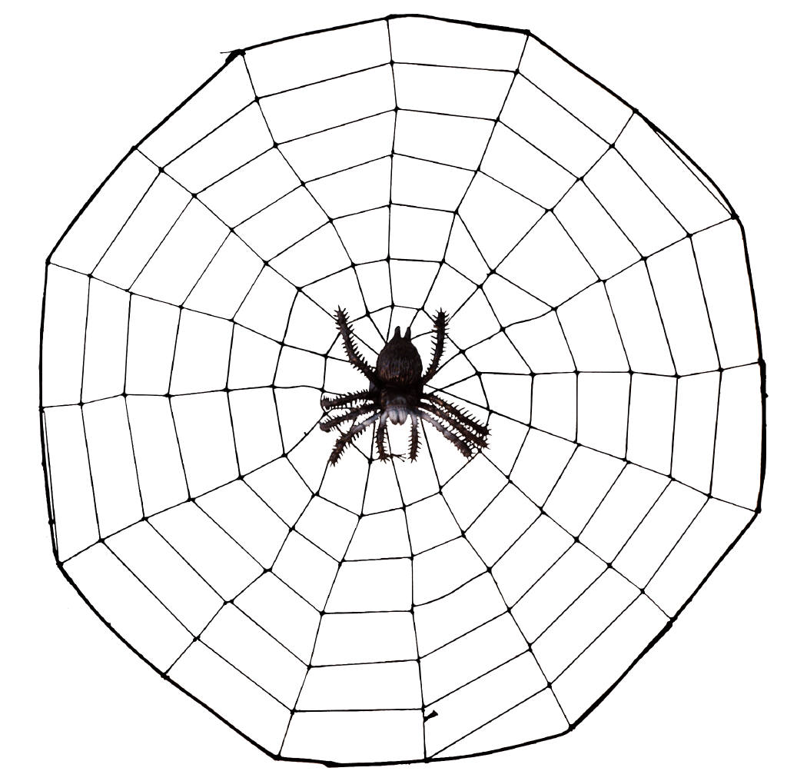October Reading Incentive: “A Web of Good Books”

October can be a creepy month…especially with so many spiders lurking about! During the month of October our students will be reading fiction story books. The goal this month is for students to read 15 minutes a night and record their minutes on a calendar. They will also complete 1 story web for a fiction story they have read. The story web is located on the back of this month’s calendar. Students should use sentences and/or pictures to fill in the bubbles on their story web. A completed calendar and web should be sent back to school at the end of the month.

Students who meet this incentive will be able to participate in a spider building (snack) activity during school. The students will use a variety of snacks to create a spider of artistic proportions! After viewing everyone’s spider, the kids will get to eat their creation! Your child’s teacher will contact you about the date.

Please keep in mind the following tips:
- participation in reading incentives is a choice
- 15 minutes of nightly reading homework may count towards reading incentive minutes
- calendars and webs turned in after the end of the month will not be accepted

Thank you,
The 2nd Grade Teachers
- October
“A Web of Good Books”
Sun | Mon | Tues | Wed | Thurs | Fri | Sat
 |  |  |  |  |  | Total Minutes

Parent’s Signature: ____________________________
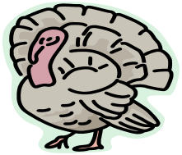
November Reading Incentive: “Gobble Up Some Good Books”

November is a great month to gobble up some good books! This month students will be thinking about books and authors they particularly enjoy as they’re reading. The goal this month is for each student to read 15 minutes a night and record their minutes on a calendar. This will include over the Thanksgiving holiday. A completed calendar should be sent to school by the end of the month.

Students who meet this incentive will get to participate in a special story-telling event with a MYSTERY story teller!

Thank you for your support!
The 2nd Grade Teachers
- November
“Gobble Up Some Good Books”
Sun | Mon | Tues | Wed | Thurs | Fri | Sat
 |  |  |  |  |  | Total Minutes
Parent’s Signature: __________________________


December Reading Incentive: “Reading with Friends and Family!”
December is a great month to read a good book to a family member or friend. This month students will choose different family members and friends to read with. Our goal is to read to at least 6 different family members and friends. One great way to read to a relative far away is to call and read the story right over the phone to them!
Students will read 15 minutes a night and record their minutes on the calendar. This does not include winter break. A completed calendar and list of family members should be sent back to school before winter break. Students who accomplish this goal will have a hot chocolate read-in at school. The best part is each student gets to choose one friend or family member to come to school to read with them. Please go ahead and invite them. They will share some hot chocolate and good books on December 18th at 9:00 am.
Sincerely,
The Second Grade Teachers

December
Sun | Mon | Tues | Wed | Thurs | Fri | Sat
List your 6 family and friends below: |  |  |  |  | Parent Signature: | Total Minutes
January Reading Incentive: “The Great Snowball Book Blitz”
January is a month of snow, snow, snow! When it is cold outside a great thing to do is snuggle up inside with a good book by the fire. Students who meet this incentive will get to participate in a special class read-in! Bring in a pillow, blanket, stuffed animal, and your favorite books!
Starting second semester we will ask students to begin a new goal of 20 minutes a night at home. Students will keep track of their minutes on their monthly calendar.

Thank you,
The 2nd Grade Teachers 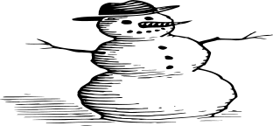
January
Sun | Mon | Tues | Wed | Thurs | Fri | Sat
 |  |  |  |  |  | Total Minutes

February Reading Incentive: “My Heart Belongs to Books!”
This month make a pledge with all your heart to reading! We are asking that each student set a goal to read 500 minutes this month. That’s only 20 minutes a day! Students should keep track of the minutes they read each day on their calendar.
A completed calendar should be turned in at the end of the month. Students who meet this incentive will receive a special treat at the end of the month. Read every day! Love it!
Thank you for your support,
The 2nd Grade Teachers
February
Sun | Mon | Tues | Wed | Thurs | Fri | Sat
 |  |  |  |  |  | Total Minutes

Parent’s Signature: _____________________
March Reading Incentive: “Harmony Reads Book Awards!”
During the month of March, students will be asked to find and read books that have received an award of some kind. Some of the different types of literature awards are listed below:
- Caldecott Award
- Newbery Award
- Corretta Scott King Award
- William Allen White Award

Students should attempt to read at least three of the four award categories and record at least one book from each category that they have read this month. Students are expected to read 20 minutes a night and should record their minutes on their calendar. They may choose other books beyond the award books to complete their 20 minutes if they would like.

Award winning books are set aside in designated sections of our library. Students will be able to check out award winning books during their regular library check-out times. However we want to encourage students to look at the public library as well. You can also get a good list of award books by going to www.jocolibrary.com and clicking on the “KIDS” link or look them up online.

Students who meet this incentive will participate in a game of kickball against another 2nd grade class!
Sincerely,
The 2nd Grade Teachers
March
Sun | Mon | Tues | Wed | Thurs | Fri | Sat
 |  |  |  |  | Parent Signature: | Total Minutes
- Caldecott Award: _________________________________________________________________________________________________________
- Newbery Award: __________________________________________________________________________________________________________
- Corretta Scott King Award:_______________________________________________________________________________________________
- William Allen White Award: _____________________________________________________________________________________________


April Reading Incentive: “Harmony Reads Up a Storm!”

Students are also asked to find and read weather-related information as well as different types of texts. Students are expected to read 20 minutes a night and record it on their calendar. They may choose other books beyond the incentive requirements to fulfill their time. Some of the different types of texts are listed below. The order of information read does not matter as long as the different types of text are explored.
- Magazine Article
- Newspaper Article
- Internet Article
- Fiction Book
During the month of April, our class will be divided up in two teams, hurricanes and tornadoes. As a class we are going to see which team can read the most minutes! The reward for meeting this incentive is a Twisted Ice Cream Party! The Team coming in 2nd place will serve the ice cream to the 1st place team before eating their own ice cream treats. This will be a fun competition for good sports only! Your child’s teacher will contact you to let you know when your class is having their celebration! Let’s see you can read the most minutes!

Sincerely,
The 2nd Grade Teachers

April
Sun | Mon | Tues | Wed | Thurs | Fri | Sat
 |  |  |  |  |  | Total Minutes

Parent’s Signature: ___________________________
May Reading Incentive: “Hook-a-Book”

Splash into summer with good books! This month students are expected to read books of their choice. They may choose from a favorite genre, author or series. Students are expected to read 20 minutes a night and record their time on their calendar. This is the last month for reading minutes to reach student’s yearly reading totals. All minutes will be due at the end of the month. Help make that last push to help transition readers into the summer!
Students who meet this incentive will participate in a second grade wide extra recess time on a beautiful day in May! Please also record your favorite book YOU read this year to help make a class recommendation list for next year!
Thank you for all your support and focus on reading this year! We really appreciate the time and energy you put into your child’s reading success.
Thank You,
The 2nd Grade Teachers 
May
Sun | Mon | Tues | Wed | Thurs | Fri | Sat
 |  |  |  |  |  | Total Minutes
Parent’s Signature: _____________
Write your favorite books you read this year : ________________________________________________________


