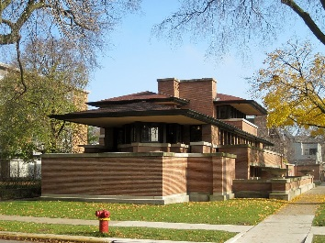
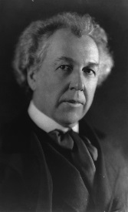
Frank Lloyd Wright and the Robie House—An Internet Scavenger Hunt
Use the Internet to find the answers and learn more about an influential and famous architect, Frank Lloyd Wright, and the Robie House, the setting of the book we will be reading, The Wright 3. Make sure to include the full URL where you found the information for each question. You must use a minimum of 5 different reputable sites for your answers.
- Where was Frank Lloyd Wright born and what years did he live?
Answer:
URL:
- Where did Frank Lloyd Wright go to college and what degree(s) did he obtain?
Answer:
URL:
- What did Frank Lloyd Wright name his home? Where was the home located and how large was it?
Answer:
URL:
- What is Frank Lloyd Wright’s style of architecture called? Explain that type of architecture.
Answer:
URL:
- In addition to his own home, what are three other buildings that Frank Lloyd Wright is famous for designing? Where are they located?
Answer:
URL:
- What are two other things that Wright is famous for designing that AREN’T buildings?
Answer:
URL:
- How many total building designs did Frank Lloyd Wright complete and that were built during his lifetime?
Answer:
URL:
- What were two of the major influences on Frank Lloyd Wright’s design?
Answer:
URL:
- In your opinion, why is Frank Lloyd Wright considered the most influential architect of the 20th Century? Use two facts that you find to support your opinion.
Answer:
URL:
- What is one additional interesting fact that you learned about Frank Lloyd Wright during your research? (You may list more! )
Answer:
URL:
The Robie House
- List the 5 dates that you consider the most important in the “life” of the Robie House and tell why each date was important.
Answer:
1.
2.
3.
4.
5.
URL:
- What makes the Robie House a good example of the Prairie style? Identify at least 5 features that support your opinion.
Answer:
URL:
- Some people have compared the Robie House to a tree house. The Germans nicknamed is dampfer (steamship) architecture. What does the Robie House look like to you? Why?
Answer:
- Using the floor plans provided as well as the pictures and information found on the websites to compare and contrast your home to the Robie House. Find at least 5 significant similarities and 5 significant differences.
Answer:

Similarities:
1.
2.
3.
4.
5.

Differences:
1.
2.
3.
4.
5.
- What is your favorite feature of the Robie House? Why is it your favorite?
Answer:

