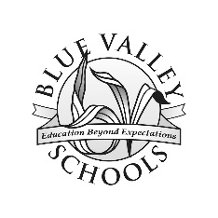
Blue Valley Word List 2
about | don’t | know | purple | want
after | door | laugh | read | warm
air | eat | listens | right | watched
again | eight | lived | river | water
all | every | long | saw | went
almost | fast | love | says | were
along | find | made | school | when
always | first | many | sea | where
another | five | makes | seven | white
answered | friend | more | should | why
any | four | myself | six | world
around | funny | need | small | would
baby | get | new | some | yellow
ball | give | next | something | your
because | green | nine | take | zero
been | going | old | tell
before | gone | once | ten
black | good | only | thank
blue | heard | open | their
brown | help | others | them
called | high | orange | there
caused | him | our | these
colors | home | out | think
could | house | over | thought
days | how | people | three
dear | I’ll | pink | today
does | into | plays | two
dog | jump | pretty | very
done | just | pulls | walk

