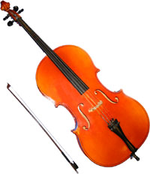
5th grade Strings Enrollment 2015-2016
Student Name___________________________
Classroom Teacher_______________________

Instrument you plan to play________________

Parent Name____________________________
Parent email____________________________
Parent Cell Phone________________________
Home Address___________________________

For Families with two custodial parents:
Parent Name_________________________
Parent Email_________________________
Parent Cell Phone_____________________
Home Address________________________

Please let me know if I can help you as we prepare for another great year!

Taryn Gervais
tgervais@bluevalleyk12.org

