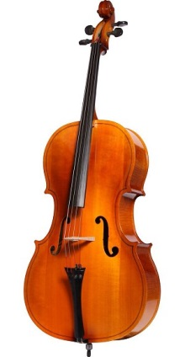
4th Grade Strings!
Student Name___________________________________
Your School_____________________________________
Classroom Teacher_______________________________
Parents’ Names__________________________________
Home Address___________________________________
Home Phone____________________________________
Parent/Guardian Phone____________________________
Parent/Guardian Email_____________________________
Important! Most communication is through email.

_______________________________________
Student Signature
Yes!
I give my child permission to enroll in Strings. I have read through the information packet with my child. I understand that our family will need to rent an instrument and purchase basic supplies.
Strings class meets throughout the entire school year, and I am ready to support my student in her/his efforts through May.

_______________________________________ Parent/Guardian Signature
*Please return this form to the office staff of your school by Friday August 21st. Thank you!

