Monthly Reading Log
Name:___________________Title(s):________________________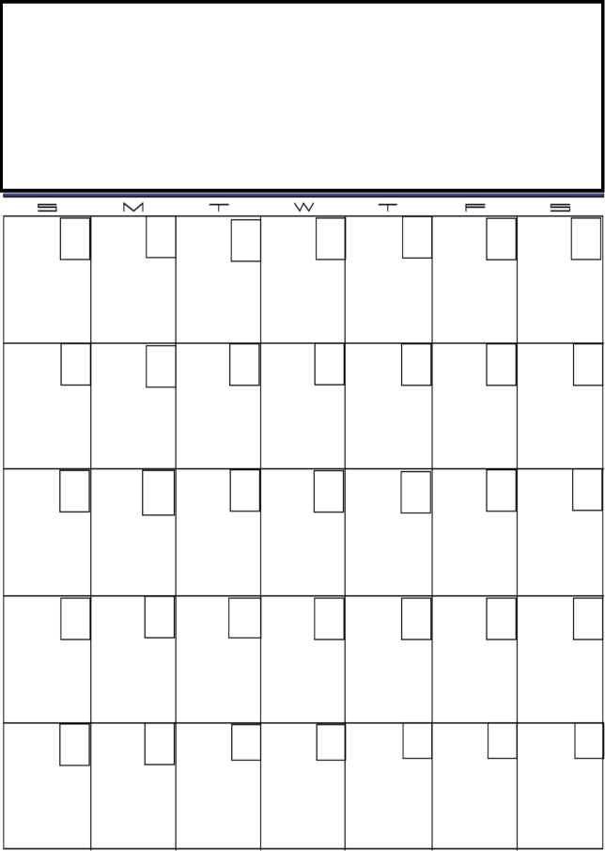
2008
Weekly Total

____________
Weekly Total

____________
Weekly Total

____________
Weekly Total

____________
Weekly Total

____________
GRAND TOTAL minutes for the Month:
____________
Total Minutes
_____________
Total Minutes
_____________
Total Minutes
_____________
Total Minutes
_____________
Total Minutes
_____________
Total Minutes
_____________
Total Minutes
_____________
Total Minutes
_____________
Total Minutes
_____________
Total Minutes
_____________
Total Minutes
_____________
Total Minutes
_____________
Total Minutes
_____________
Total Minutes
_____________
Total Minutes
_____________
Total Minutes
_____________
Total Minutes
_____________
Total Minutes
_____________
Total Minutes
_____________
Total Minutes
_____________
Total Minutes
_____________
Total Minutes
_____________
Total Minutes
_____________
Total Minutes
_____________
Total Minutes
_____________
Total Minutes
_____________
Total Minutes
_____________
Total Minutes
_____________
Total Minutes
_____________
Total Minutes
_____________
Each student is required to read at least 400 minutes per month.
My child read a total of ______________ minutes for the month.
Parent Signature: ______________________________________
Monthly Reading Log
Name:____________________ Title of Book(s): ____________________
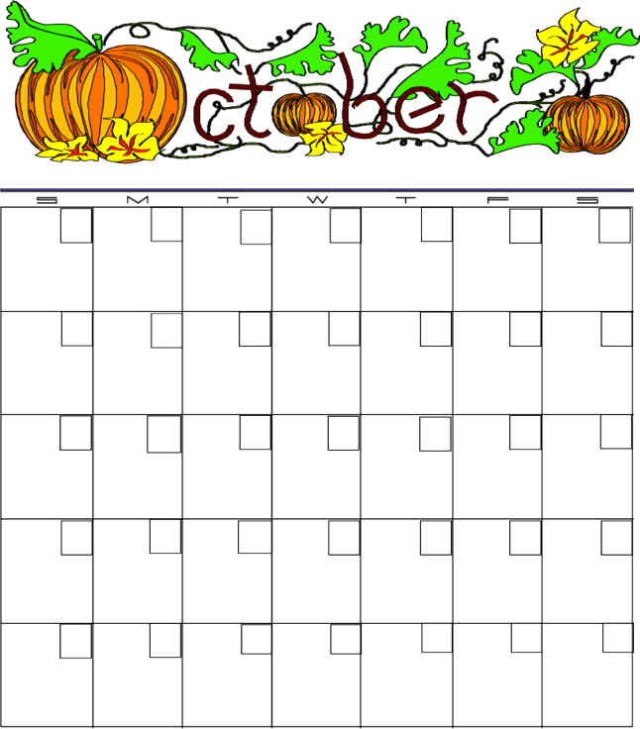
Weekly Total

____________
Weekly Total

____________
Weekly Total

____________
Weekly Total

____________
Weekly Total

____________
GRAND TOTAL minutes for the Month:
____________
Total Minutes
_____________
Total Minutes
_____________
Total Minutes
_____________
Total Minutes
_____________
Total Minutes
_____________
Total Minutes
_____________
Total Minutes
_____________
Total Minutes
_____________
Total Minutes
_____________
Total Minutes
_____________
Total Minutes
_____________
Total Minutes
_____________
Total Minutes
_____________
Total Minutes
_____________
Total Minutes
_____________
Total Minutes
_____________
Total Minutes
_____________
Total Minutes
_____________
Total Minutes
_____________
Total Minutes
_____________
Total Minutes
_____________
Total Minutes
_____________
Total Minutes
_____________
Total Minutes
_____________
Total Minutes
_____________
Total Minutes
_____________
Total Minutes
_____________
Total Minutes
_____________
Total Minutes
_____________
Total Minutes
_____________
Total Minutes
_____________
2008
Each student is required to read at least 400 minutes per month.
My child read a total of ______________ minutes for the month.
Parent Signature: ______________________________________
Monthly Reading Log
Name:____________________ Title of Book(s): ____________________
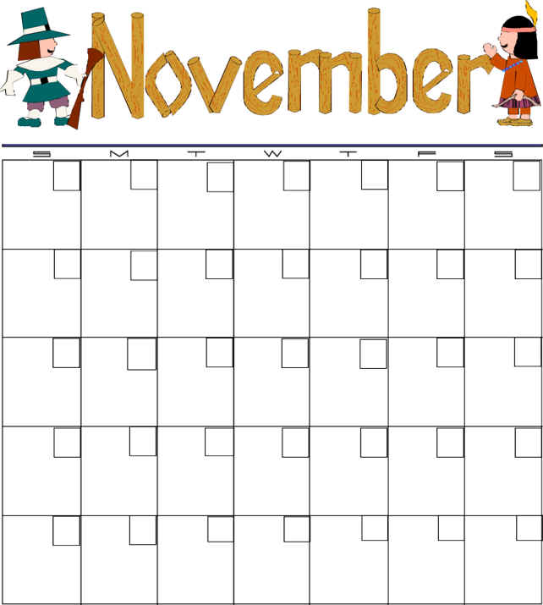
Weekly Total

____________
Weekly Total

____________
Weekly Total

____________
Weekly Total

____________
Weekly Total

____________
GRAND TOTAL minutes for the Month:
____________
Total Minutes
_____________
Total Minutes
_____________
Total Minutes
_____________
Total Minutes
_____________
Total Minutes
_____________
Total Minutes
_____________
Total Minutes
_____________
Total Minutes
_____________
Total Minutes
_____________
Total Minutes
_____________
Total Minutes
_____________
Total Minutes
_____________
Total Minutes
_____________
Total Minutes
_____________
Total Minutes
_____________
Total Minutes
_____________
Total Minutes
_____________
Total Minutes
_____________
Total Minutes
_____________
Total Minutes
_____________
Total Minutes
_____________
Total Minutes
_____________
Total Minutes
_____________
2008
Each student is required to read at least 400 minutes per month.
My child read a total of ______________ minutes for the month.
Parent Signature: ______________________________________
Monthly Reading Log
Name:____________________ Title of Book(s): ____________________

2008
Weekly Total

____________
Weekly Total

____________
Weekly Total

____________
Weekly Total

____________
Weekly Total

____________
GRAND TOTAL minutes for the Month:
____________
Total Minutes
_____________
Total Minutes
_____________
Total Minutes
_____________
Total Minutes
_____________
Total Minutes
_____________
Total Minutes
_____________
Total Minutes
_____________
Total Minutes
_____________
Total Minutes
_____________
Total Minutes
_____________
Total Minutes
_____________
Total Minutes
_____________
Total Minutes
_____________
Total Minutes
_____________
Total Minutes
_____________
Total Minutes
_____________
Total Minutes
_____________
Total Minutes
_____________
Total Minutes
_____________
Total Minutes
_____________
Total Minutes
_____________
Total Minutes
_____________
Total Minutes
_____________
Total Minutes
_____________
Total Minutes
_____________
Total Minutes
_____________
Total Minutes
_____________
Total Minutes
_____________
Total Minutes
_____________
Total Minutes
_____________
Total Minutes
_____________
Each student is required to read at least 400 minutes per month.
My child read a total of ______________ minutes for the month.
Parent Signature: ______________________________________

Monthly Reading Log
Name:____________________ Title of Book(s): ____________________

Weekly Total

____________
Weekly Total

____________
Weekly Total

____________
Weekly Total

____________
Weekly Total

____________
GRAND TOTAL minutes for the Month:
____________
2009
Total Minutes
_____________
Total Minutes
_____________
Total Minutes
_____________
Total Minutes
_____________
Total Minutes
_____________
Total Minutes
_____________
Total Minutes
_____________
Total Minutes
_____________
Total Minutes
_____________
Total Minutes
_____________
Total Minutes
_____________
Total Minutes
_____________
Total Minutes
_____________
Total Minutes
_____________
Total Minutes
_____________
Total Minutes
_____________
Total Minutes
_____________
Total Minutes
_____________
Total Minutes
_____________
Total Minutes
_____________
Total Minutes
_____________
Total Minutes
_____________
Total Minutes
_____________
Total Minutes
_____________
Total Minutes
_____________
Total Minutes
_____________
Total Minutes
_____________
Total Minutes
_____________
Total Minutes
_____________
Total Minutes
_____________
Total Minutes
_____________
Each student is required to read at least 400 minutes per month.
My child read a total of ______________ minutes for the month.
Parent Signature: ______________________________________

Monthly Reading Log
Name:____________________ Title of Book(s): ____________________
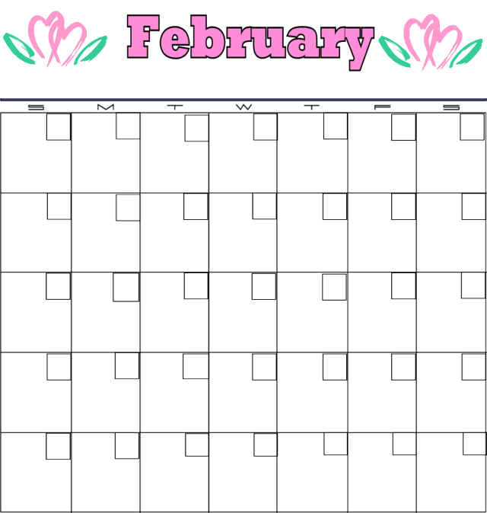
2009
Weekly Total

____________
Weekly Total

____________
Weekly Total

____________
Weekly Total

____________
Weekly Total

____________
GRAND TOTAL minutes for the Month:
____________
Total Minutes
_____________
Total Minutes
_____________
Total Minutes
_____________
Total Minutes
_____________
Total Minutes
_____________
Total Minutes
_____________
Total Minutes
_____________
Total Minutes
_____________
Total Minutes
_____________
Total Minutes
_____________
Total Minutes
_____________
Total Minutes
_____________
Total Minutes
_____________
Total Minutes
_____________
Total Minutes
_____________
Total Minutes
_____________
Total Minutes
_____________
Total Minutes
_____________
Total Minutes
_____________
Total Minutes
_____________
Total Minutes
_____________
Total Minutes
_____________
Total Minutes
_____________
Total Minutes
_____________
Total Minutes
_____________
Total Minutes
_____________
Total Minutes
_____________
Total Minutes
_____________
Each student is required to read at least 400 minutes per month.
My child read a total of ______________ minutes for the month.
Parent Signature: ______________________________________

Monthly Reading Log
Name:____________________ Title of Book(s): ____________________
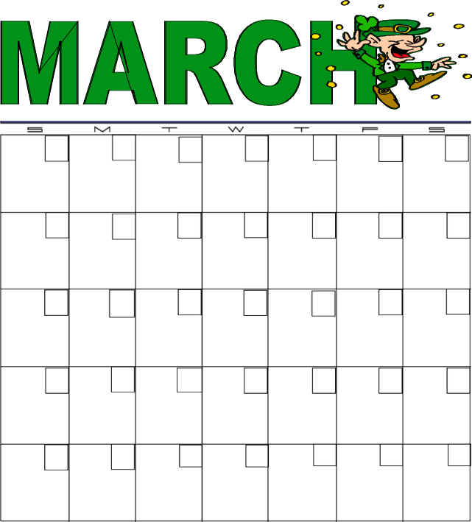
2009
Weekly Total

____________
Weekly Total

____________
Weekly Total

____________
Weekly Total

____________
Weekly Total

____________
GRAND TOTAL minutes for the Month:
____________
Total Minutes
_____________
Total Minutes
_____________
Total Minutes
_____________
Total Minutes
_____________
Total Minutes
_____________
Total Minutes
_____________
Total Minutes
_____________
Total Minutes
_____________
Total Minutes
_____________
Total Minutes
_____________
Total Minutes
_____________
Total Minutes
_____________
Total Minutes
_____________
Total Minutes
_____________
Total Minutes
_____________
Total Minutes
_____________
Total Minutes
_____________
Total Minutes
_____________
Total Minutes
_____________
Total Minutes
_____________
Total Minutes
_____________
Total Minutes
_____________
Total Minutes
_____________
Total Minutes
_____________
Total Minutes
_____________
Total Minutes
_____________
Total Minutes
_____________
Total Minutes
_____________
Total Minutes
_____________
Total Minutes
_____________
Total Minutes
_____________
Each student is required to read at least 400 minutes per month.
My child read a total of ______________ minutes for the month.
Parent Signature: ______________________________________
Monthly Reading Log
Name:____________________ Title of Book(s): ____________________
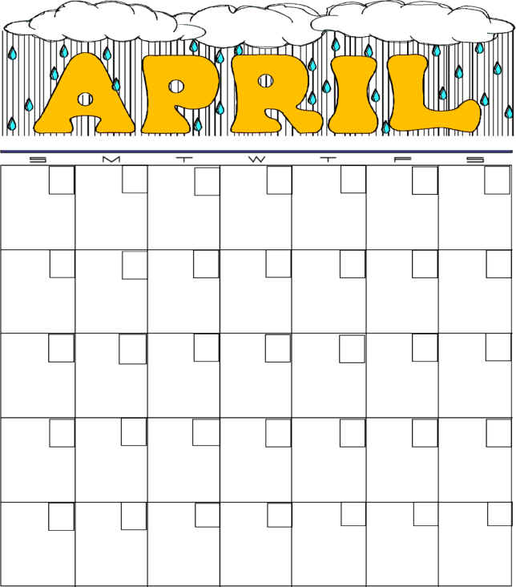
2009
Weekly Total

____________
Weekly Total

____________
Weekly Total

____________
Weekly Total

____________
Weekly Total

____________
GRAND TOTAL minutes for the Month:
____________
Total Minutes
_____________
Total Minutes
_____________
Total Minutes
_____________
Total Minutes
_____________
Total Minutes
_____________
Total Minutes
_____________
Total Minutes
_____________
Total Minutes
_____________
Total Minutes
_____________
Total Minutes
_____________
Total Minutes
_____________
Total Minutes
_____________
Total Minutes
_____________
Total Minutes
_____________
Total Minutes
_____________
Total Minutes
_____________
Total Minutes
_____________
Total Minutes
_____________
Total Minutes
_____________
Total Minutes
_____________
Total Minutes
_____________
Total Minutes
_____________
Total Minutes
_____________
Total Minutes
_____________
Total Minutes
_____________
Total Minutes
_____________
Total Minutes
_____________
Total Minutes
_____________
Total Minutes
_____________
Total Minutes
_____________
[Type a quote from the document or the summary of an interesting point. You can position the text box anywhere in the document. Use the Text Box Tools tab to change the formatting of the pull quote text box.]
Each student is required to read at least 400 minutes per month.
My child read a total of ______________ minutes for the month.
Parent Signature: ______________________________________
Monthly Reading Log
Name:____________________ Title of Book(s): ____________________
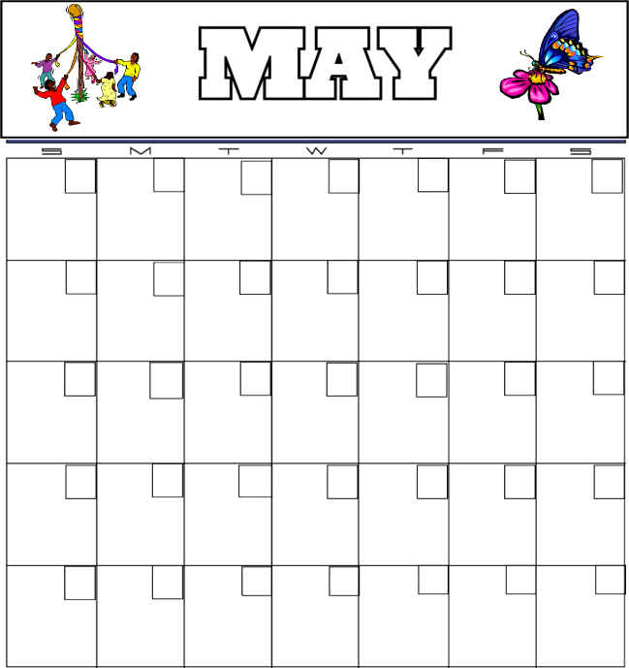
2009
Weekly Total

____________
Weekly Total

____________
Weekly Total

____________
Weekly Total

____________
Weekly Total

____________
GRAND TOTAL minutes for the Month:
____________
Total Minutes
_____________
Total Minutes
_____________
Total Minutes
_____________
Total Minutes
_____________
Total Minutes
_____________
Total Minutes
_____________
Total Minutes
_____________
Total Minutes
_____________
Total Minutes
_____________
Total Minutes
_____________
Total Minutes
_____________
Total Minutes
_____________
Total Minutes
_____________
Total Minutes
_____________
Total Minutes
_____________
Total Minutes
_____________
Total Minutes
_____________
Total Minutes
_____________
Total Minutes
_____________
Total Minutes
_____________
Total Minutes
_____________
Total Minutes
_____________
Total Minutes
_____________
Total Minutes
_____________
Total Minutes
_____________
Total Minutes
_____________
Total Minutes
_____________
Total Minutes
_____________
Total Minutes
_____________
Total Minutes
_____________
Each student is required to read at least 400 minutes per month.
My child read a total of ______________ minutes for the month.
Parent Signature: ______________________________________

