ORDER BY
JANUARY
8
PLEASANT RIDGE MIDDLE SCHOOL
BULLDOG BASKETBALL

$13.50 BADGER Badger
20 Basic
Performance C2
Tee
$16.50 BADGER C2
BASIC
PERFORMANCE LONG SLEEVE T EE
$10.50 BRODER 5.3 OZ HEAVY COTTON
T-SHIRT
$14.50 BRODER 5.3 OZ HEAVY COTTON
LONG SLEEVE T- SHIRT
$23.00 CHAMPION Champion Double
Dry Fleece Hood
Available in 1 other color.

$14.50 CHAMPION Champion®
Vapor® Short- Sleeve Crew Neck T-Shirt
Available in 1 other color.
$24.00 UNDER ARMOUR Under Armour®
Locker T Men's Short-Sleeve Crew Neck T- Shirt
$29.00 UNDER ARMOUR UA Locker Tee
Longsleeve

UPCHARGES APPLY FOR LARGER SIZES

Contact Brad Holliday: bholliday@bsnsports.com
Team Coordinator Marc Modelski: MLModelski@bluevalleyk12.org
ORDER ONLINE www.bsnteamsports.com Enter Access Code To Login

Access Code
models5R6F

Order 1/5 to 1/8

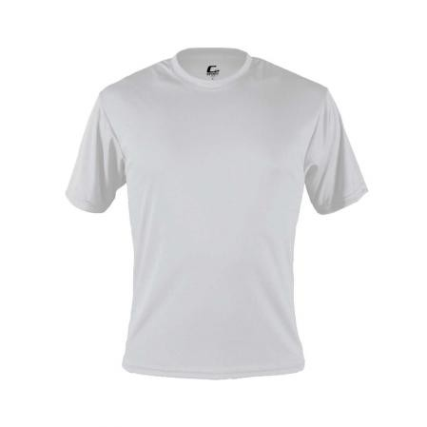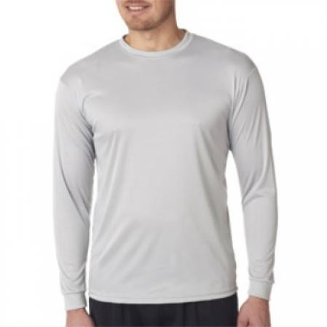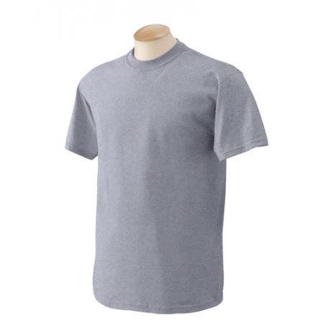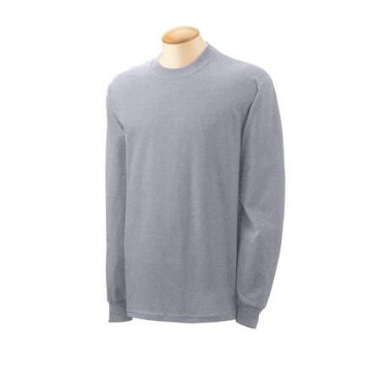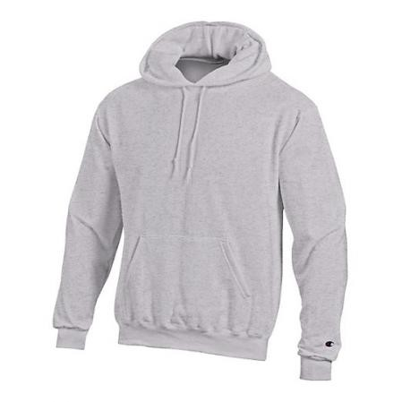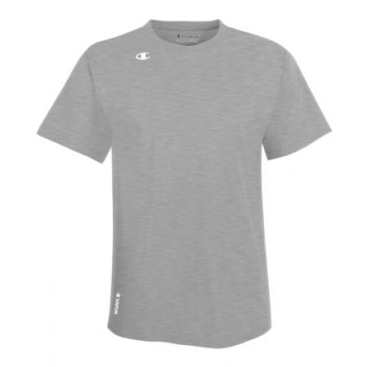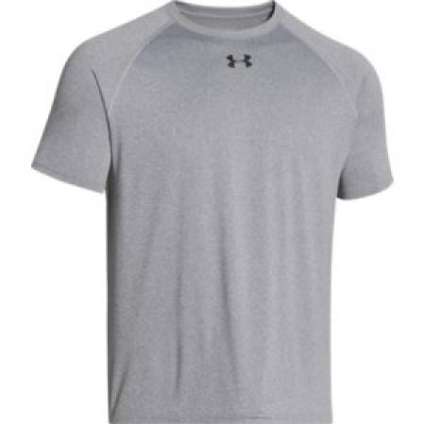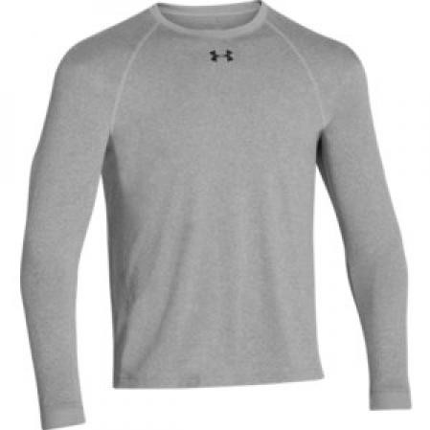No orders will be accepted after the deadline.

